ELAC MEETING Agenda
November 12, 2020 at 9:00am
Virtual Meeting: ELAC/Coffee Chat Zoom Link
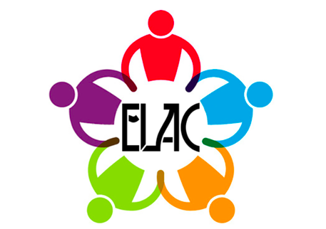
- Welcome
- Introductions
- Purpose of ELAC
- Elections
  - ELAC Board
  - DELAC Representative Alternate
- Presentation: School Plan for Student Achievement – Input Opportunity for Our Community

